Install new agent in oem..

In first you can, telnet the ip to remote the target.

Target

IP 10.250.200.69/ODTKOMS..

After telnet success you add the “IP,hostname” in server source “OEM12” and target.

You can add using user OS root and add the ip and hostname in /etc/hosts

source

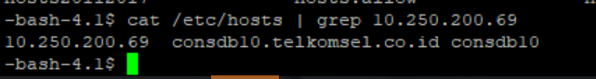

Target

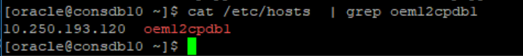

1. Setup-add target-add target manualy

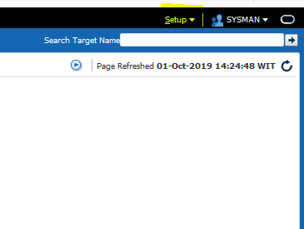

1. Choose add host target and kilik add host

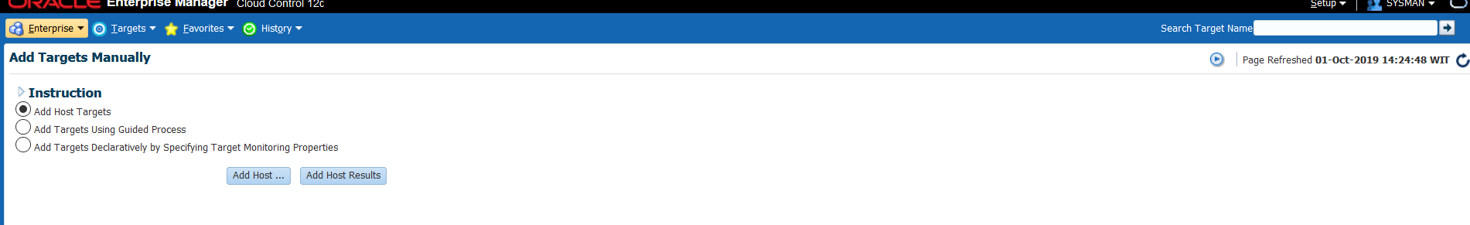

1. You kilik add and pick the platform the server in user, and you can write hostname in host

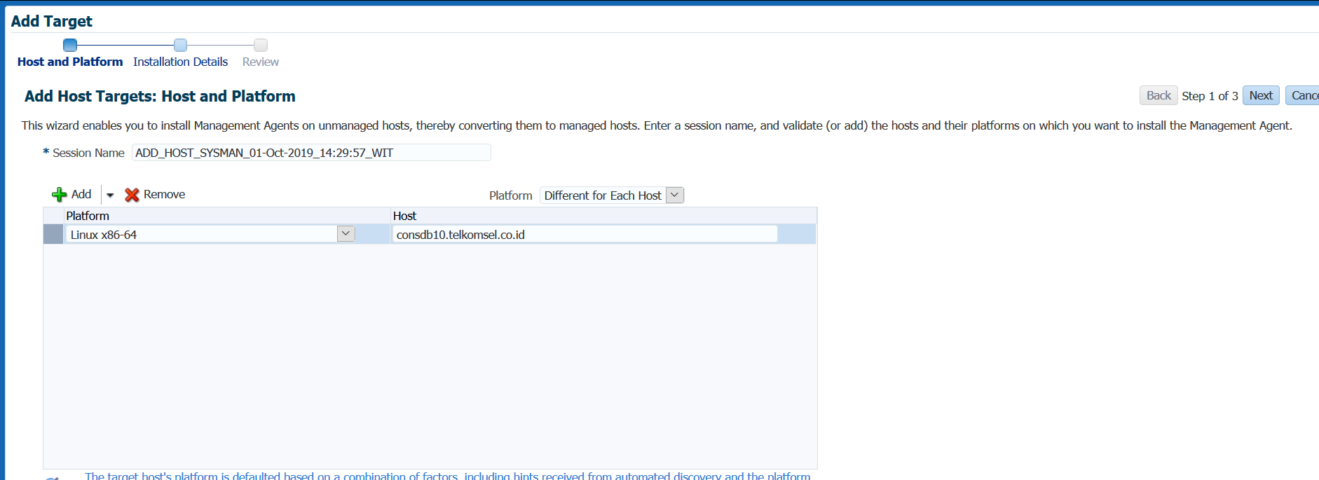

1. Ga ke capture step selanjutnya..

Ntar selanjutnya pilih fress agent install.

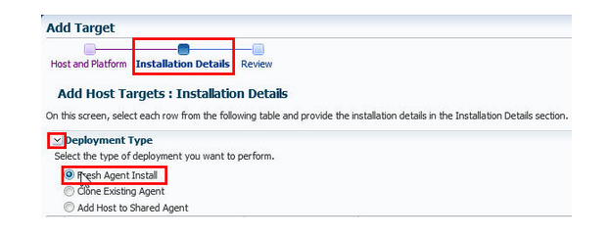

1. Lalu masukan ntar credential name dengan pass owner os dan password, dan setelah itu masukin path yg akan di installin agent..(lupa di capture, mau coba daftarin yg lain harus masukin di etc/hosts dulu)

Cd /apps/oracle

Mkdir agent_inst

/apps/oracle/agent_inst/

Selanjutanya tinggal di next..

Rekomendasi

https://docs.oracle.com/cd/E25178_01/install.1111/e22624/install_agent.htm